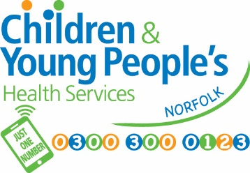
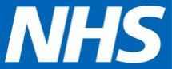
Children & Young People’s Health Services
Cringleford Business Centre
Cringleford
Norwich
Norfolk
NR4 6AU
Tel: 0300 300 0123
Parentline: 07520631590
www.justonenorfolk.nhs.uk

School Height & Weight Check – National Child Measurement Programme (NCMP)

Each year in England, school children in Reception and Year 6 have their height and weight checked at school as part of the National Child Measurement Programme. Height and weight measurements are used to calculate weight status. The information gathered allows services to plan how to support families to lead healthy lives.

Your child’s class will take part in this year’s programme.

The checks are carried out by trained staff from the Healthy Child Programme. Children are measured fully clothed, except for their coats and shoes, in a private space away from other pupils. A member of the school staff may be present during screening. We are working with the school to ensure COVID 19 precautions are followed to keep your child safe.

Please see page 2 of this letter on how to opt your child out of these checks.

NCMP results – what happens next:
- Healthy Weight - You will not receive a results letter if your child is in the healthy weight range. You can talk to a member of our team about your child’s height and weight results by contacting us on the details above.

- Underweight - You will receive a letter within 6 weeks with the results and further information. A member of our team will contact you to talk about the results.

- Overweight - You will receive a letter with the results within 6 weeks. This letter will also include useful links to further information available on our Just One Norfolk website.

- Very Overweight - You will receive a letter within 6 weeks with the results This letter will also include useful links to further information available on our Just One Norfolk website. A member of our team may contact you to talk
about your child’s results. You can also get in contact with us using the above details.

Opting your child out of the National Child Measurement Programme

If you are happy for your child to be measured, you do not need to do anything.

If you do not wish your child’s height and weight to be checked, please follow the steps below in the grey box. Children will not be made to take part if they do not want to.

If you wish to opt your child out of the National Child Measurement Programme (NCMP) please follow the steps below:

- Contact us by 7th December 2020 if you do not opt out by this date there is a chance your child may be seen
- Call us on 0300 300 0123 or
- email: CCS-TR.NCMPScreeningOptOut@nhs.net
- Leave the following information:-
  - child’s full name
  - NHS Number (if known)
  - date of birth
  - current home address
  - school they attend
  - check/test you’re opting them out of

It is very important that we receive all the above information when you are opting your child out.

We provide this service to help protect the health of your child as part of our public task as a health service provider. Your child’s school has provided us with your contact details. We will update your child's electronic health record of the outcome of our screening programme. http://www.cambscommunityservices.nhs.uk/docs/default-source/ig-privacy-notices/pn-hcp-service-v1-2-sept-2018.pdf?sfvrsn=16
For information regarding the data collection and how it’s used please see separate attachment – NCMP data collection.

Please do not hesitate to contact the team if you have any queries.

Yours faithfully,

Healthy Child Programme (HCP) team

