
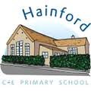
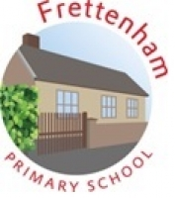

Phonics Information Sheet
Autumn 2019

Letters and Sounds
The children will be taught synthetic phonics via the Letters and Sounds programme. The programme is designed to begin in the Early Years Foundation Stage (EYFS) and is made up of six phases, which are taught in daily phonics lessons throughout EYFS and Key Stage 1. The programme covers the introduction of letter phonemes, blending and segmenting skills, common exception words (or tricky words) and high frequency words, before teaching alternative graphemes and alternative pronunciations, tenses and suffixes.

Useful Links
The Letters and Sounds website is full of useful information on the phases and how phonics is taught progressively across each:
http://www.letters-and-sounds.com
This website also has lots of resources and games that children can access at home.

Sounds of the English Phonic Code- Synthetic Phonics:
https://www.youtube.com/watch?v=IwJx1NSineE

Phonics Play:
http://www.phonicsplay.co.uk

ICT Games:
http://www.ictgames.com/literacy.html

‘Letters and Sounds’ High Frequency Words
First 100 Words by Phase
a  an  and  as  at  back  big  but  can  dad  get  got  had  him  his  if  in  is  it  mum  not  of  off  on  up  go  I  into  no  the  to  Phase 2 | down  for  look  now  see  that  them  then  this  too  will  with  all  are  be  he  her  me  my  she  they  was  we  you  Phase 3 | children  from  help  it’s  just  went  come  do  have  like  little  one  out  said  so  some  there  were  what  when  Phase 4 | about  by  came  day  don’t  here  house  I’m  made  make  old  put  saw  time  very  your  asked  called  could  looked  Mr  Mrs  Oh  people  their  Phase 5

