Week 10 Newsletter



🌟 Rudolph Flapjack

This week in our Food Explorers classes we have been making some very festive, very tasty Rudolph flapjack. A teacher from one of the schools asked me to share this recipe with everyone as she said that it looked and smelled so good that she wanted everyone to be able to have a try at making it.
This recipe is always a hit and my family love it. Let me know if you give it a try!

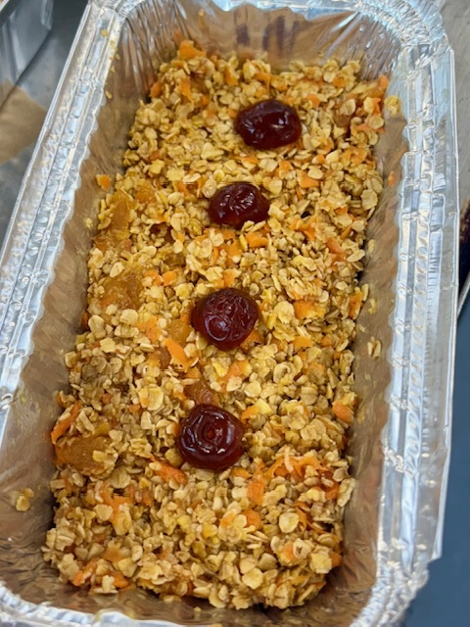

Ingredients
200g butter
100g golden syrup
50g light brown sugar
300g oats
2 carrots, grated
Zest 1 orange
100g dried apricots, chopped
8 glace cherries, halved

Method
First pre-heat the oven to 160ºC, 140ºC, gas mark 3. Line a 6” square baking tin with greaseproof paper.

Melt the butter, sugar and syrup in a saucepan.

Mix the oats, sugar, carrots, orange zest and apricots together in a large bowl. Pour in the melted butter mixture and stir well.

Pour the mixture into the baking tin and press down firmly. Place the cherries evenly across the mixture and lightly press in, you will want a Rudolph nose on every square when you cut it!

Bake for 40-45 minutes, allow to cool before slicing. Into 16 squares.

